IS 354 – COMPUTER MODELING AN D SIMULATION ASSIGNMENT

i.

Five hundred dogs live in the wooded grassy area near the Kigamboni Bridge. Every year 100

puppies (dogs) are born. Life near the bridge takes its toll, though, and every year 120 dogs die.

How many dogs will live near the bridge in 10 years?

**Solution**

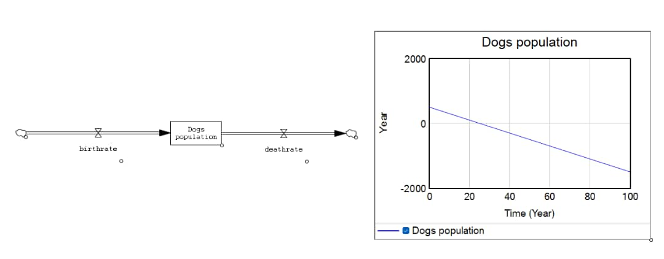

ii.

A pond is treated weekly with a chemical to ensure that the number of bacteria is kept

low. It is estimated that the chemical kills 68% of all bacteria. Between the weekly

treatments, it is estimated that 600 million new bacteria appear. There are un million

bacteria at the start of a particular week.

a) Write down a recurrence relation for u n+1 , the number of millions of bacteria at

the start of the next week.

b) Find the limit of the sequence generated by this recurrence relation and explain

what the limit means in the context of this question.

**Solution**

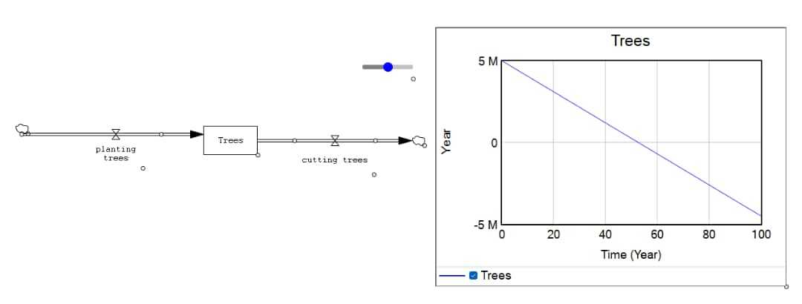

iii.

In 1972 the world’s known reserves of copper were about 775 million metric tons, of which about

1.85 million metric tons are milled annually (every year) at present. Make the temporary

assumption that the world population is not growing and industrializing, increasing the demand

for copper exponentially, but instead is at some (unrealistic) equilibrium so that the demand for

copper is constant. At the current rate of consumption, approximately how long will the known

reserves last? (Hint: Increasing/decreasing the time scale, and running the model several times

until you find the numbers of years after which the copper reserves drop to zero will surely help)

**Solution**

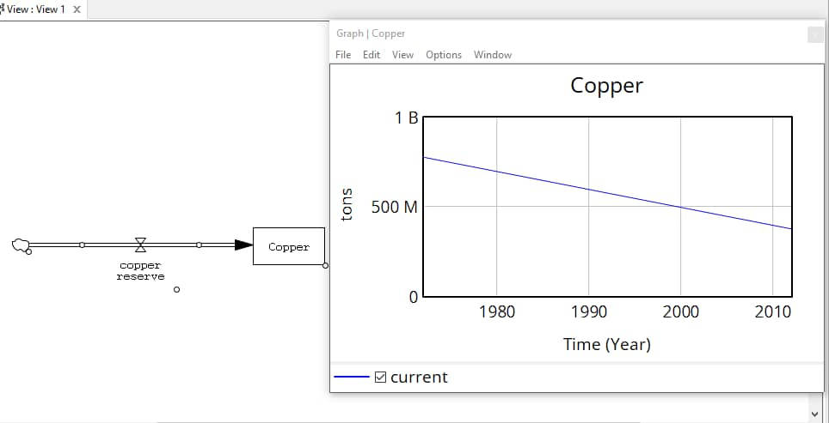

Question 2(i)  
A sequence is defined by recurrence relation un+1 = aun+b, where a and b are constants with u5=5,  
u6 = 1, u7=7.  
a) Find algebraically the values of a and b  
b) Hence find the value of u9 and u3

**Solution**

Given;  
Un+1 = aun + b  
Un+1 = next term  
Un = next term  
a) Un+1 = au5 + b  
U6=a(5) + b  
1 = 5a + b......eq i  
Un+1 = au6 + b  
U7 = a(1) + b  
U7 = a + b......eq ii  
Make ‘a’ the subject  
7 = a + b  
a = 7 – b....... eq iii  
Substitute eq iii into i  
1 =5(7 – b) + b  
1 = 35 – 5b + b  
1 = 35 – 4b  
1 – 35 = -4b  
-34/-4 = -4b/-4  
b = 8.5  
Therefore, the value of constant b is 8.5

From;  
a = 7 – b  
a = 7 – 8.5  
a = -1.5  
The value of constant a = -1.5  
b) U8 = au7 + b  
U8 = a(a + b) + b  
U8 = -1.5(-1.5+ 8.5) + 8.5  
U8 = -1.5(7) + 8.5  
= -10.5 + 8.5  
U8 = -2  
U9 = a(u8) + b  
U9 = (-1.5)(-2) + 8.5  
U9 = 3 + 8.5  
U9 = 11.5  
The value of u9 is 11.5  
U5 = a(u4) + b  
U5 = -1.5(u4) + 8.5  
5 = -1.5(u4) + 8.5  
5 – 8.5 = -1.5u4  
U4 = 2.3  
U4 = a(u3) + b  
2.3 = -1.5(u3) + 8.5  
2.3 – 8.5 = -1.5u3  
U3 = 4.13  
The value of U3 is 4.13

ii.

A pond is treated weekly with a chemical to ensure that the number of bacteria is kept

low. It is estimated that the chemical kills 68% of all bacteria. Between the weekly

treatments, it is estimated that 600 million new bacteria appear. There are un million

bacteria at the start of a particular week.

a) Write down a recurrence relation for u n+1 , the number of millions of bacteria at

the start of the next week.

b) Find the limit of the sequence generated by this recurrence relation and explain

what the limit means in the context of this question.

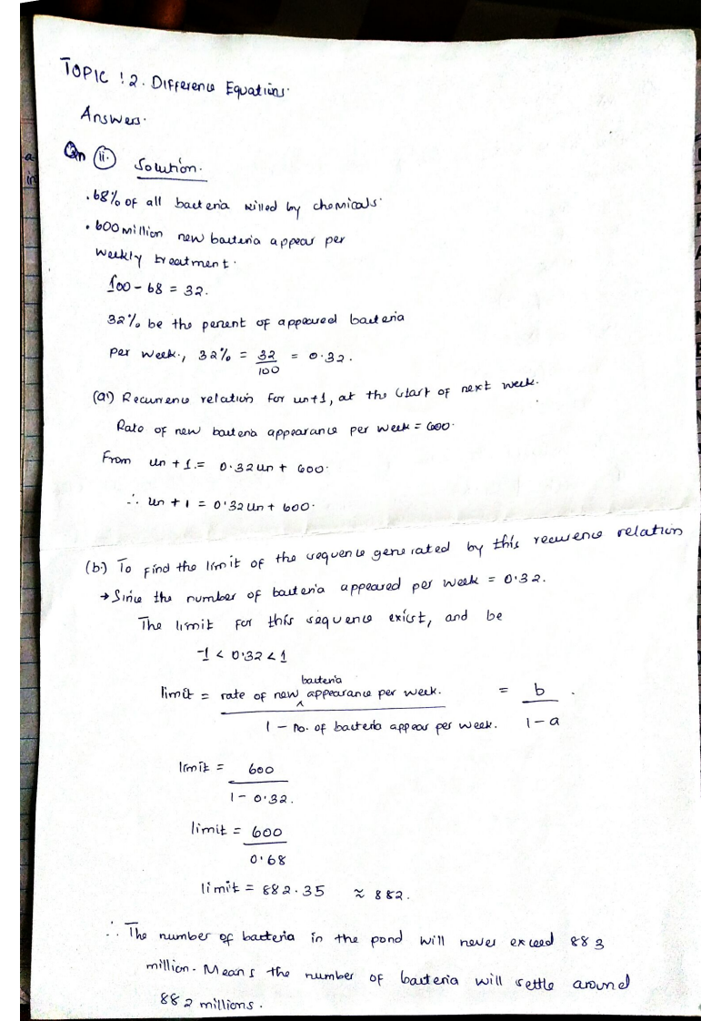

iv. Inflation causes things to cost more, and for our money to buy less Suppose inflation

decreases the value of money by 5% each year. In other words, if you have $1 this year,

next year it will only buy you $0.95 worth of stuff. How much will $100 buy you in 20

years ?

**Solution**

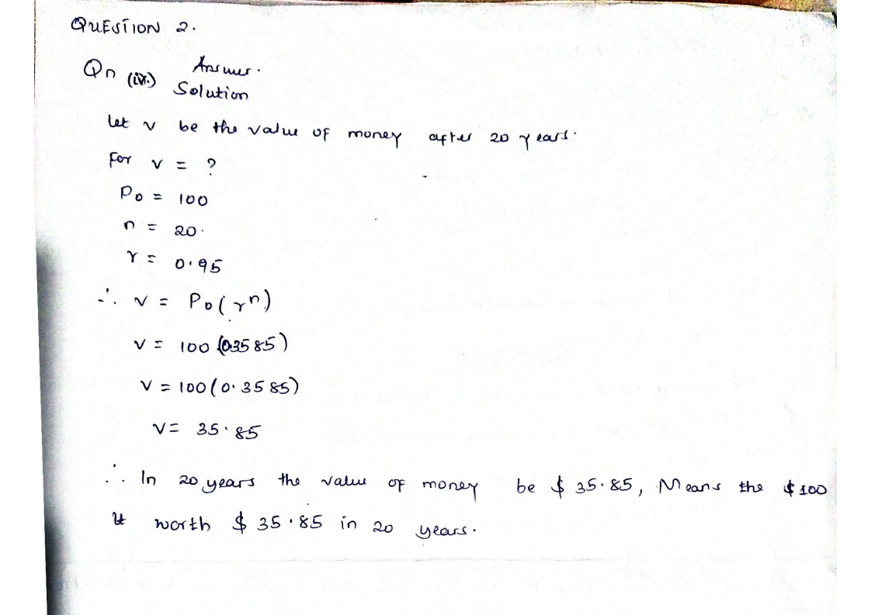

Question 3

**Answers**

1. Malthus proposed two societal changes to avoid the doom-and-gloom outcome he was predicting:

* Moral restraint:

He believed that people should exercise self-restraint in terms of having fewer children, especially when resources were scarce.

* Positive checks:

Malthus believed that natural disasters, famine, disease, and war were necessary to control population growth and prevent the overshoot of resources. He suggested that such "positive checks" were inevitable and should not be prevented.

1. Malthus's predictions did not occur due to a variety of factors, including technological advancements, the development of new agricultural techniques, and the expansion of trade and transportation networks. These factors allowed for an increase in food production and the efficient distribution of resources, which helped to keep pace with the growing population.
2. Malthus's theory and the logistic growth model share some similarities in their focus on population growth and limiting factors. Both models acknowledge that population growth is limited by available resources and that there is a carrying capacity beyond which growth cannot continue. However, the logistic growth model is more sophisticated and takes into account factors such as competition for resources, carrying capacity, and feedback mechanisms that can limit growth. Malthus's theory, on the other hand, is based on a simpler linear model that does not account for these complexities.